# Metabolic impacts of climate change (Answer key)

This activity is adapted from the following research article: Dillon, M. E., Wang, G., & Huey, R. B. (2010). Global metabolic impacts of recent climate warming. *Nature*, *467*(7316), 704-706. <https://www.nature.com/articles/nature09407>

## [Link to the visualization](https://insectphenology.ml/Climate-Change-Metabolism/)

## [Link to TrEnCh-Ed](https://trench-ed.github.io/#)

## Objectives

* Understand what latitudes are warming the fastest.
* What is metabolism and how do metabolic rates depend on size and temperature?
* Explore the latitudinal gradient in changes in energy metabolism.
* How do changes in energy use compare to temperature changes across latitudes?

## Cross-cutting concepts -- *Next Generation Science Standards*

* Cause and effect
* Systems and system models
* Energy and Matter
* Structure and function

## Standards

Life Science Standards (LS)

|  |  |
| --- | --- |
| HS-LS2-2 | Use mathematical representations to support and revise explanations based on evidence about factors affecting biodiversity and populations in ecosystems of different scales. |
| HS-LS2-4 | Use mathematical representations to support claims for the cycling of matter and flow of energy among organisms in an ecosystem |

## Instructions

First, read the introduction of the visualization. That will give you the background to understand and complete this activity.

### Latitudinal gradients in climate change

Both observations of recent climate change and model projections of future climate change indicate faster warming toward the poles, particularly in the arctic. You can use this mapping application made by NASA to explore global patterns of recent climate change: <https://data.giss.nasa.gov/gistemp/maps/index_v4.html>. Choose to plot “anomalies”, which indicate differences in temperature between a selected period and a baseline period (the default baseline is 1951-1980). Use the example plot or create your own plot to answer the following questions:

1. Where has recent warming been the strongest? What else do you notice regarding spatial patterns of warming?

The warming has been the strongest on the land masses with hot spots in Antarctica, Europe and East Asia. It is strong as well in the Arctic.

1. List two reasons why you think the pattern you observed may occur.

Any of those listed below or other reasonable answers.

There are several long standing explanations for the pattern listed below. New mechanisms have been uncovered in recent years so even if your explanation isn’t on the list below its possible future research will support your explanation.

1. Light colored area polar sea ice reflects much of the sunlight that reaches the surface. As the sea ice melts, more dark polar waters that absorb more radiation are exposed and temperatures increase.
2. Climate warming is altering some large weather systems that transport heat to the poles.
3. The thin atmosphere in the poles allows the air to warm up more with less energy. Also, lesser humidity results in energy directly raising temperatures rather than evaporating water.

(See also: <https://www.sciencedaily.com/releases/2017/05/170518083039.htm>).

### Metabolism and temperature dependence

Let’s explore what the steepening curve means for increasing rates of energy use in cool and warm environments. We’ll consider ectothermic, or cold-blooded, organisms so we can assume that the animal’s body temperature approximates the temperature of its surroundings. On the figure, start at a cool temperature along the curve and draw a horizontal arrow indicating a potential increase in body temperature. Next draw a horizontal arrow of the same length starting at a warmer temperature. For both horizontal arrows, draw vertical lines up to the metabolic rate curve. (You may need to try a few different locations and horizontal arrow lengths to get this to work within the figure.)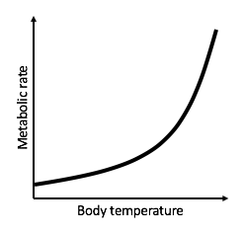

Compare the lengths of the vertical lines representing the potential increase in metabolic rate. Use your drawing to explain whether the increase in metabolic rate is greater in a warm or cold environment with the same temperature increase.



The increase in metabolic rate is greater in a warm environment.

### 

### 

### 

### 

### Does climate warming increase energy use more in tropical or temperate regions?

Use your knowledge from the previous two sections to state and explain two contrasting hypotheses for how climate warming increases rates of energy use in tropical (warm, low latitude) and temperate (cool, high latitude) regions:

H1: Climate warming increases rates of energy use more in tropical regions.

Explanation: The increase in metabolic rate from a given temperature rise is greater in a warm environment.

H2: Climate warming increases rates of energy use more in temperate regions.

Explanation: The thin atmosphere in the poles allows the air to warm up with less energy. Therefore, the poles heat up quicker and have a larger temperature increase than tropical regions.

### Visualization

The visualization allows you to select locations and examine how temperatures and estimated rates of metabolism have shifted over recent years.

Use the visualization to test your hypotheses. Which hypothesis is better supported by the data? Explain your response.

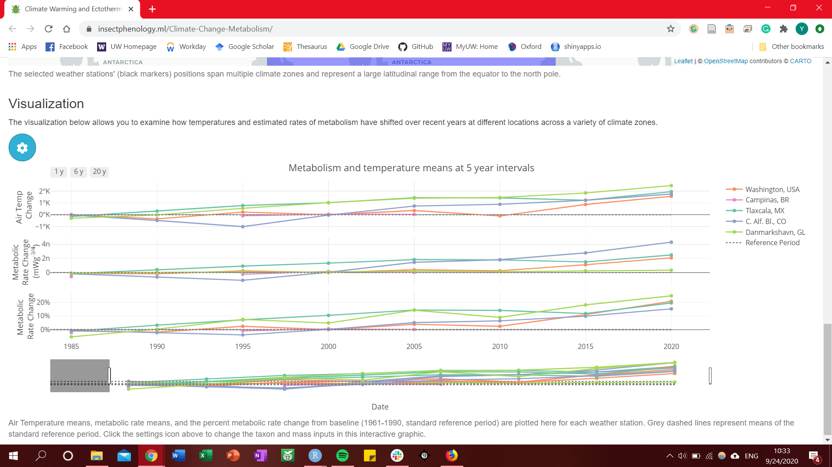

The visualization shows that in terms of percent metabolic rate change, the polar region has the greatest change. However, in absolute metabolic rate change, the temperate region has the greatest change. This points to both hypotheses having credence in their impact on organisms.

### Questions

1. The metabolic rate discussed above is for a resting animal. How do you think activity affects metabolic rate? How might results differ if we were to consider active metabolic rates?

Activity increases metabolic rates. Species that require active movements for foraging, defense, mating etc. will result in greater active metabolic rates. Regions with more of such animals will have a greater percent active metabolic rate change.

1. The metabolic rates assume that an animal is able to consume sufficient food to meet its energy demands. How might climate warming impact the amount of food available for consumption and the ability of the animals to consume the food?

Many plants and animals are changing their behavior and shifting their range due to climate change. The range shift can create a trophic mismatch where the phenology of consumer and that of resource organisms do not align. Some examples include insects that depend on flowers emerging too late or migrating birds that specialize in certain caterpillars migrating too early. In other scenarios, animals are forced to shift their range to seek a tolerable climate, which creates new competitions. In addition, animals will have to consume more food to maintain the increased metabolic rates, which can intensify competition.